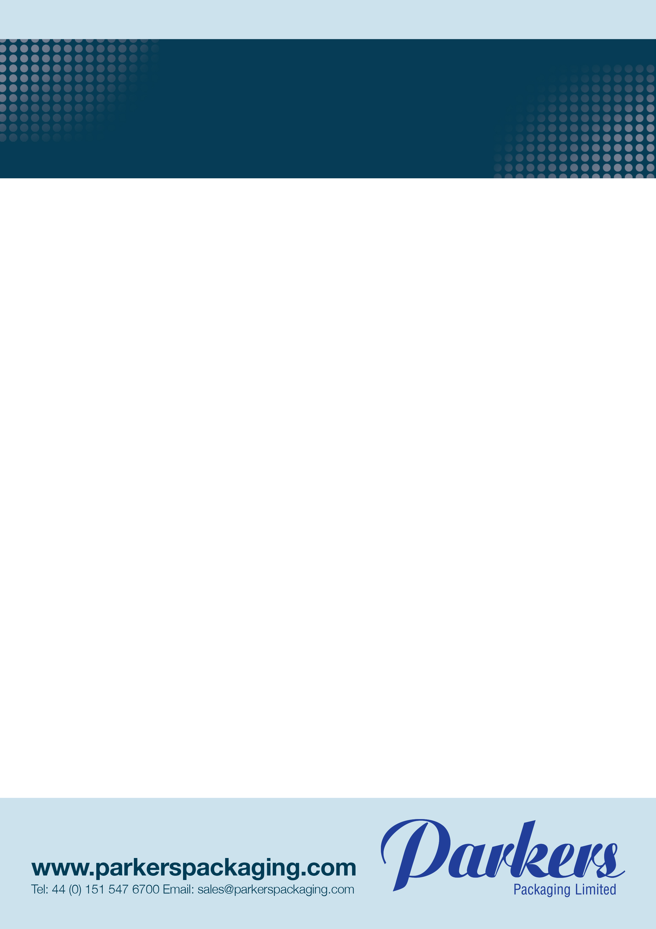

**Description:** 4 Litre rectangular container & lid combi pack

**Product codes:** P4000CL-R (Red) P4000CL-B (Blue) P4000CL-G (Green) P4000CL-Y (yellow)

**Container Dimensions:** Length top 222mm +/- 1mm **Lid Dimensions:** Length 226mm +/- 1mm

Width top 162mm +/- 1mm Width 166mm +/- 1mm

Height 149mm+/- 1mm Height 10mm+/- 1mm

Weight 93g +/- 5% Weight 32.2g +/- 5%

**Material:** Polypropylene, widely recyclable & suitable for direct food contact.

Suitable for domestic freezing, however care must be taken when handling.

Recommended filling at ambient or chilled temperatures.

Intended use for dairy products.

**Colours:** Red, blue, green & yellow

**Packing:** 40 units per box

**Box dimensions** 552 x 400 x 324mm

**Pallet Dimensions:** Length 1200mm

Width 800mm

Height 144mm

Weight 12-21kgs

**Stacking:** Maximum 1 pallet high. Customers should make internal trials to determine the viability of stacking and transportation once filled.

**Quality:** Deviations in the product specifications of 0.025% (i.e. 25 items per 100,000) are considered acceptable in the industry and therefore cannot be construed as defect.

Works orders including full traceability information will be held for a minimum period of twelve months from the date of manufacture.

**The material complies with the material and articles in contact regulation (EC)1935/2004, food contact plastics regulation (EU) 10/2011 and regulation (EC) 2023/2006 good manufacturing practices.**

**The user of the product is responsible for ensuring that the finished food packaging complies with the applicable migration limits in the food itself under actual conditions of use.**

Issue 1 23/03/2022

**Technical Data Sheet**

4 Litre rectangular Container & lid combi pack